Thermal noise floor estimations:

**5 cm cubic cavity 1542 nm** calculation von Thomas Legero (ZIM cavity report)

|  |  |  |  |
| --- | --- | --- | --- |
|  | ULE-Substrat und IBS-coating | FS-Substrat und IBS-coating | FS-Substrat und AlGaAs-Coating |
| Rauschbeitrag Spacer | 0,016 Hz/Hz0,5 | 0,016 Hz/Hz0,5 | 0,016 Hz/Hz0,5 |
| Rauschbeitrag Substrate | 0,253 Hz/Hz0,5 | 0,60 Hz/Hz0,5 | 0,60 Hz/Hz0,5 |
| Rauschbeitrag Coating | 0,200 Hz/Hz0,5 | 0,195 Hz/Hz0,5 | 0,049 Hz/Hz0,5 |
| Therm. Rauschen absolut | 0,229 Hz/Hz0,5 | 0,145 Hz/Hz0,5 | 0,057 Hz/Hz0,5 |
| Therm. Rauschlimit in ADEV | **1,4x10-15** | **0,9x10-15** | **0,4x10-15** |

Estimation for thermal noise floor ADEV for **12 cm** cavity: sigma_y=sqrt(2ln2 x f) x sqrt(G_L]/L, i.e. sigma_y is proportional to 1/L. scaling factor for 12 cm cavity compared to 5 cm cavity is 2,4 (ingnoring the contribution of the longer spacer):

|  |  |  |  |
| --- | --- | --- | --- |
|  | ULE-Substrat und IBS-coating | FS-Substrat und IBS-coating | FS-Substrat und AlGaAs-Coating |
| Therm. Rauschlimit in ADEV | **0,58x10-15** | **0,375x10-15** | **0,16x10-15** |

For **2.5 cm** Spacer:

|  |  |  |  |
| --- | --- | --- | --- |
|  | ULE-Substrat und IBS-coating | FS-Substrat und IBS-coating | FS-Substrat und AlGaAs-Coating |
| Therm. Rauschlimit in ADEV | **2.8x10-15** | **1.8x10-15** | **0,8x10-15** |

For **2.0 cm** Spacer:

|  |  |  |  |
| --- | --- | --- | --- |
|  | ULE-Substrat und IBS-coating | FS-Substrat und IBS-coating | FS-Substrat und AlGaAs-Coating |
| Therm. Rauschlimit in ADEV | **3.5x10-15** | **2.25x10-15** | **1.0x10-15** |

Calculation from Garrett Cole:

Maurice and Ronald - I just finished running the HKUST cavity thermal noise calculations. Assuming a **12 cm long ULE** spacer (just going off of your previous design as this is not specified in the RFQ) with fused silica substrates and our **1156 nm** crystalline coatings, here are the results: See attached for the details of the noise components:

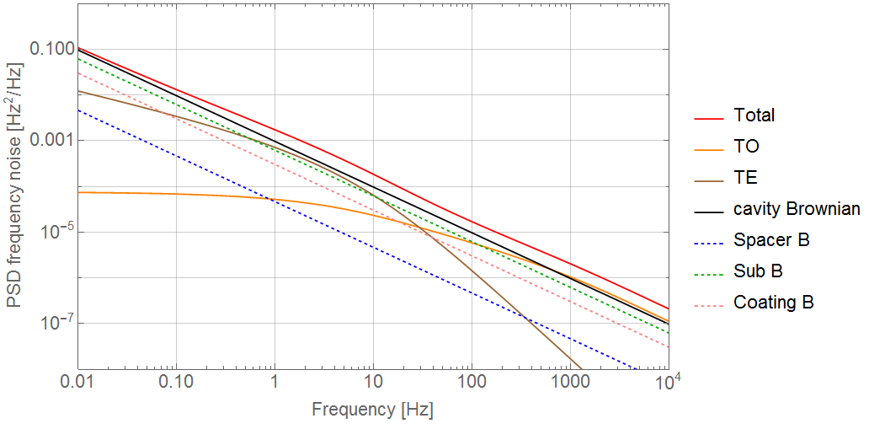

After 1 s of averaging the thermal-noise limited Allan Deviation for the cavity would be **1.6-1.9x10^-16** depending on what is assumed for the mechanical loss of the fused silica substrates. Note that this is total noise (Brownian, + substrate TE + TO, etc. and takes into account everything shown in the attached plot, but of course ignores and vibration/locking/servo/RAM related issues...

For the sake of comparison I ran a model for a "**standard" cavity with everything the same except with IBS coatings and the Allan Deviation in that case is at least twice as high at** **3.6-3.8x10^-16** (also @ 1 s).